- Screenshot of Home Wi-Fi Router Login Page
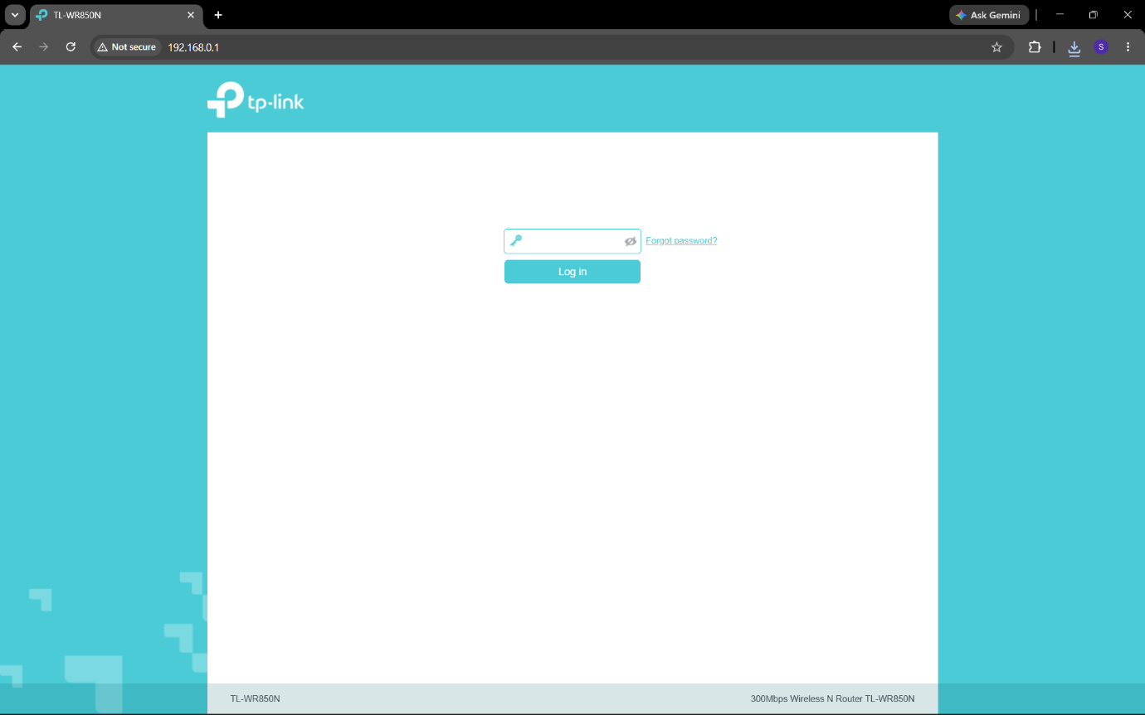

- Current Network Configuration

- Network Information | Value:
IP Address | 10.37.16.234
Subnet Mask | 255.255.255.0
Default Gateway | 10.37.16.150
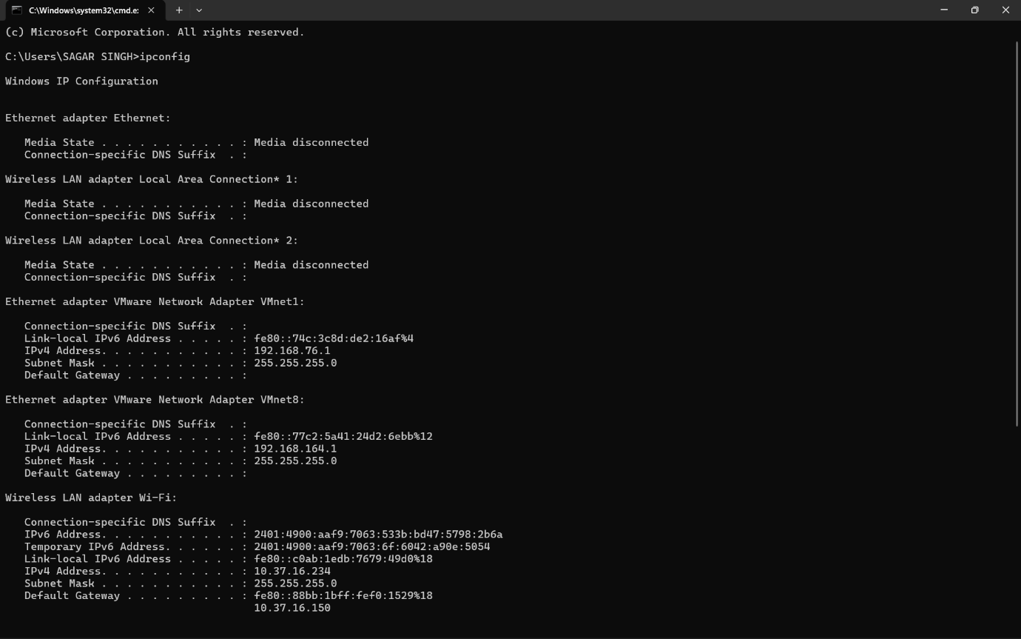

- Changing IP Address from DHCP to Static IP

- Introduction:
I changed my laptop's IP address from Obtain IP address automatically (DHCP) to a Static IP Address. After changing the IP settings, I tested the Internet connection to verify that it was working correctly. Finally, I restored the settings to Obtain IP address automatically (DHCP) to avoid future network issues.

- Step 1: Default DHCP Settings
Figure 1: IPv4 settings showing the device configured to obtain an IP address automatically (DHCP).
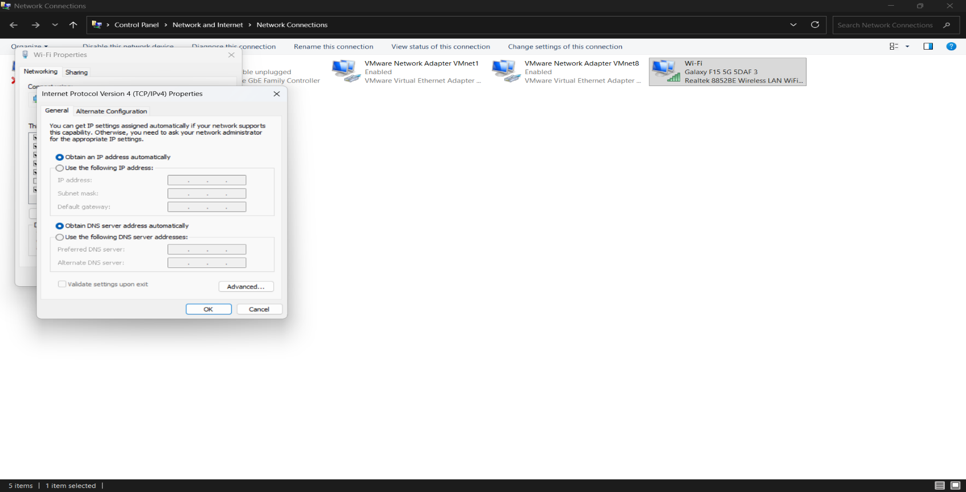

- Step 2: Static IP Configuration
Figure 2: IPv4 settings after changing the configuration to a static IP address.
- Static IP Details:
- IP Address: 10.37.16.200
- Subnet Mask: 255.255.255.0
- Default Gateway: 10.37.16.150

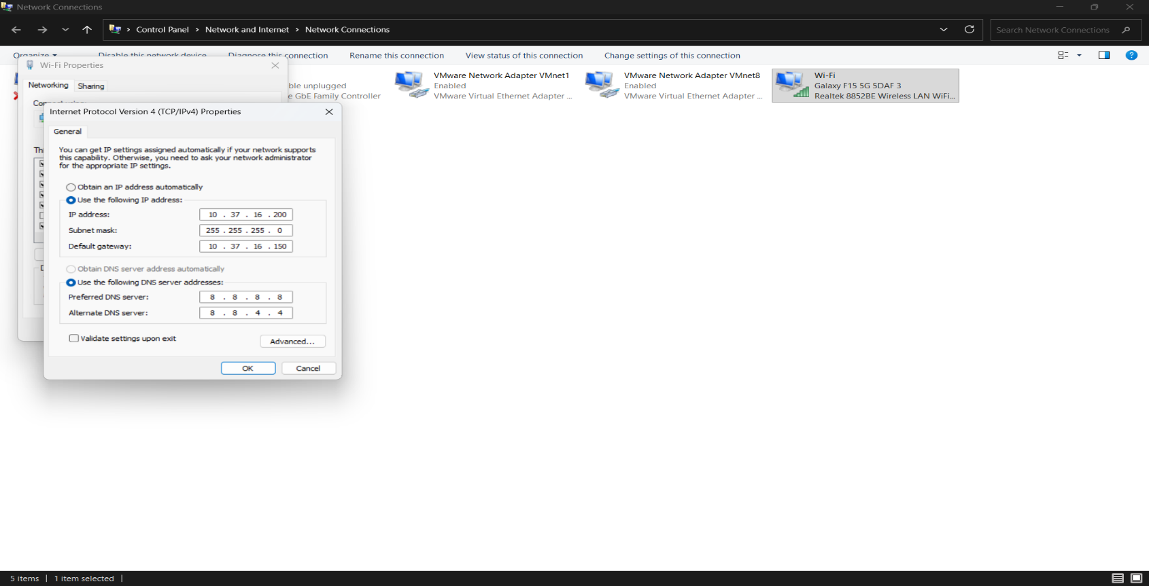
- Step 3: Verification Using Command Prompt
Figure 3: ipconfig output confirming the new static IP address, subnet mask, and default gateway.

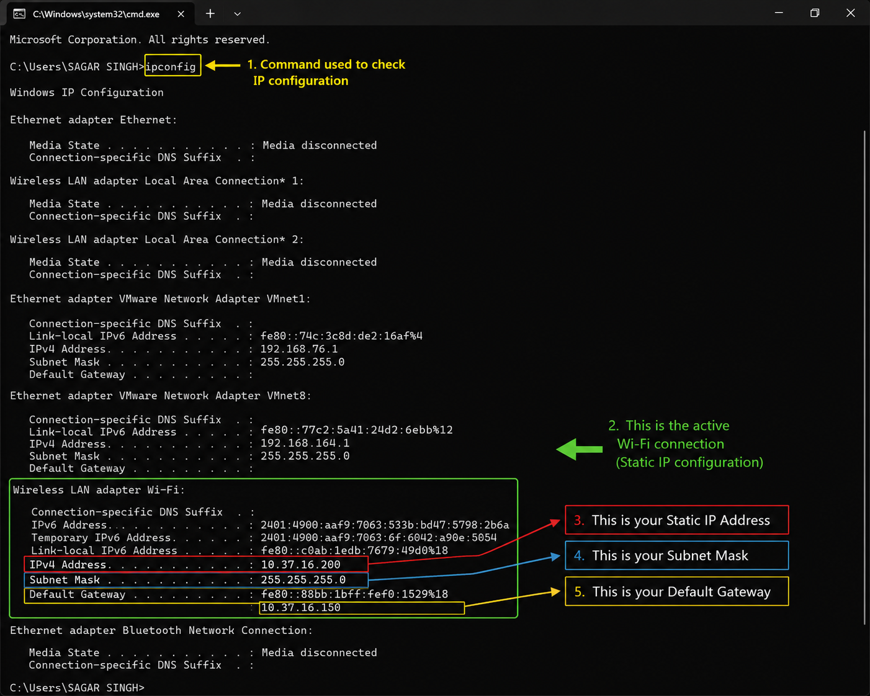
- Step 4: Internet Connectivity Test
Figure 4: Successfully accessing a website after changing the IP
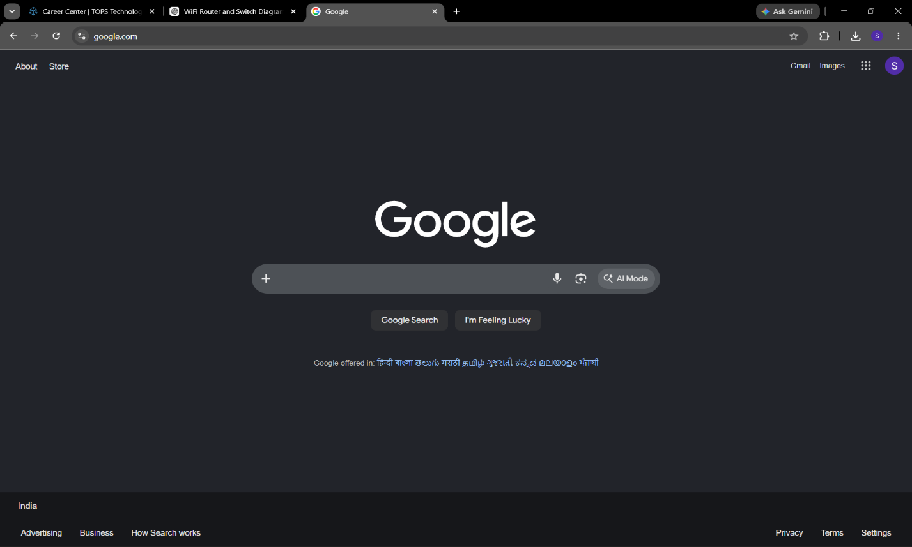
address, confirming that the Internet connection is working.

- Conclusion:
The IP address was successfully changed from DHCP to a Static IP. After testing, the Internet connection worked properly. Finally, the network settings were changed back to Obtain IP address automatically (DHCP).

- DHCP Range in Router

- DHCP Range:

- Current DHCP Range:
- Start IP: (192.168.0.100)
- End IP: (192.168.0.199)
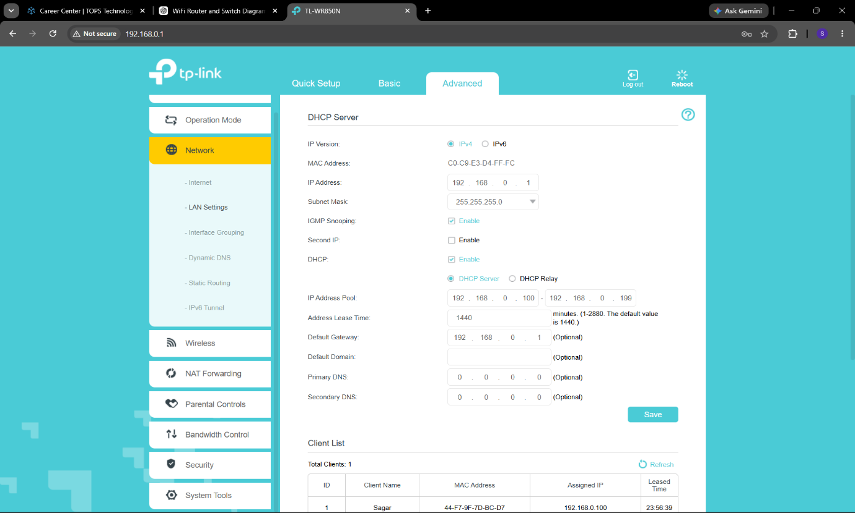
- Explanation:
If two devices are assigned the same IP address, an IP address conflict occurs. As a result, one or both devices may lose network or Internet access. This can also cause communication problems and make the network unstable.

